**Steps to create instances, install flask and run the application.**

**Create an aws instance:**

for creating instance go to the EC2 Dashboard ,select launch instance .

Give the instance name as inst01,keypair name-srver1

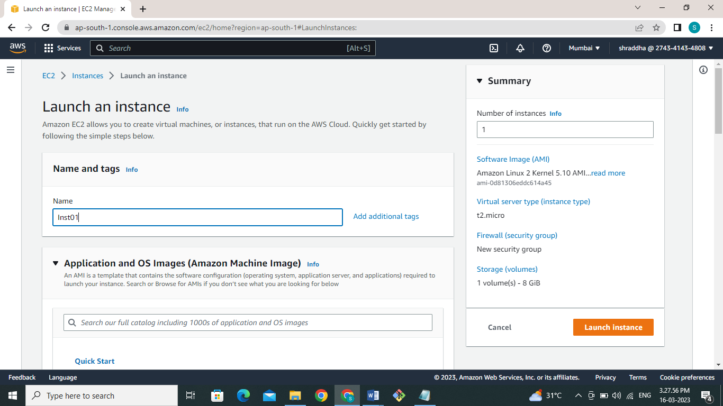

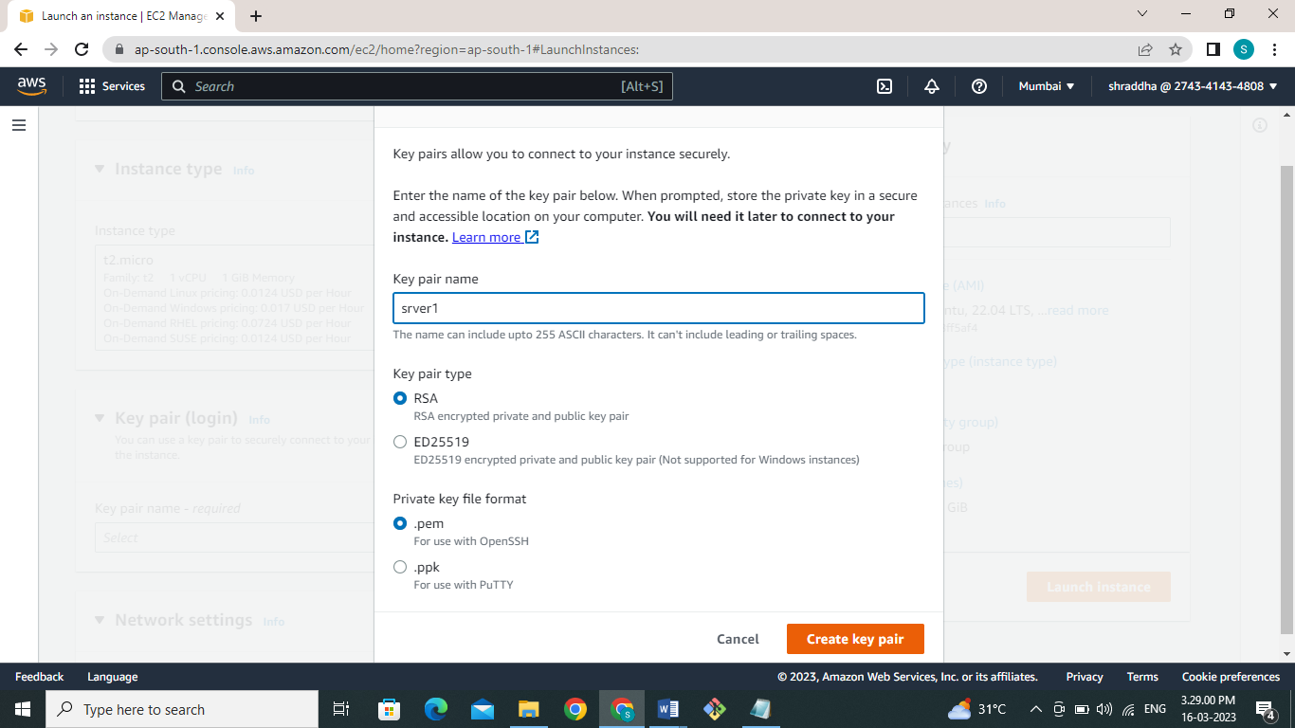

Configure the security group as shown in following screen shots .

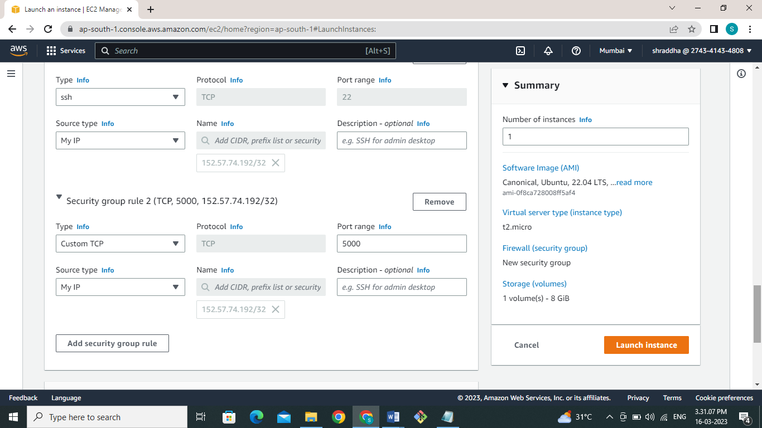

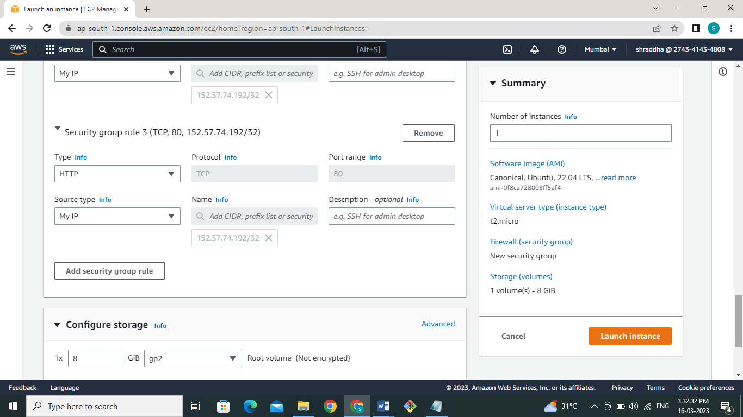

After all the configuration has been done click on **Launch Instance**. It will launch with all configurations. Similarly launch one more instance.

**Connecting instance through ssh:**

For access the instance we need to take ssh using the username and ip address of the instance as shown in following screen shots.

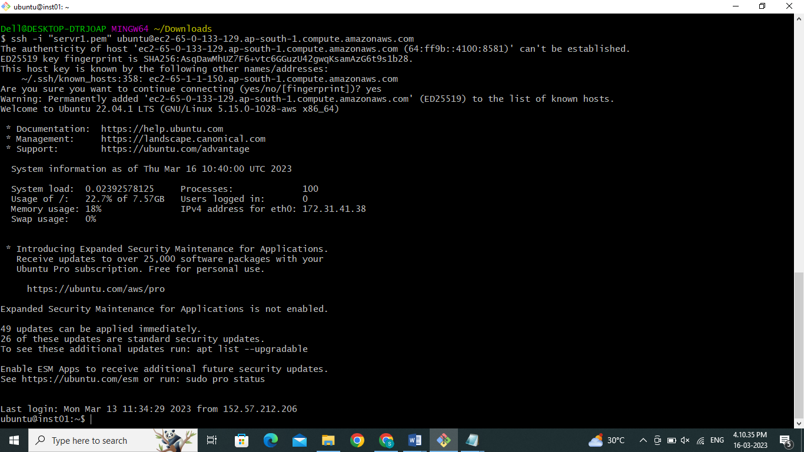

**Install Flask.**

First you need to update the system using following command

**$ sudo apt-get update**

As we are in home directory of user we need used sudo to install python virtual environment as shown below.

**$ sudo apt install python3.10-venv**

**$ python3 -m venv venv**

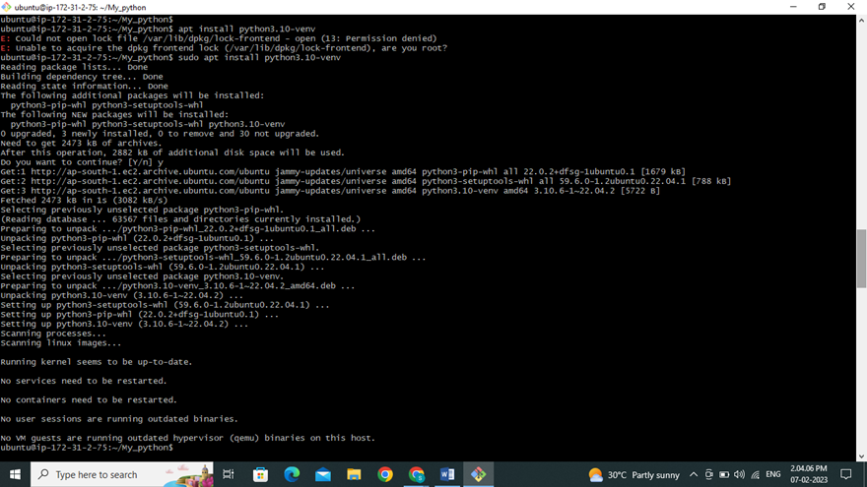

It will set up the virtual python environment for flask application and activate using flowing command.

**$. venv/bin/activate**

Here we finally ready to install flask on our machine .

**$ pip install Flask**

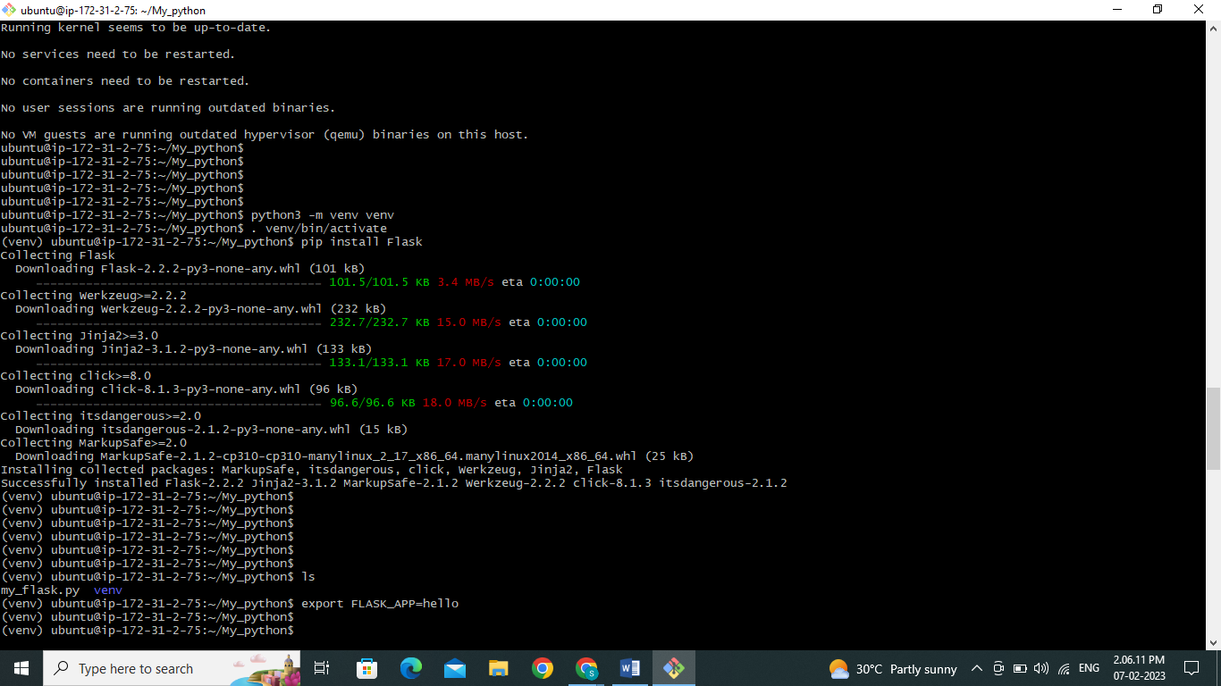

**Write application and run.**

Flask is a microframework for developers, designed to enable them to create and scale web apps quickly and simply. I have created one application of flask that will convert the url into short and then by using this link it will redirect to that page.I have used the following code for my application.

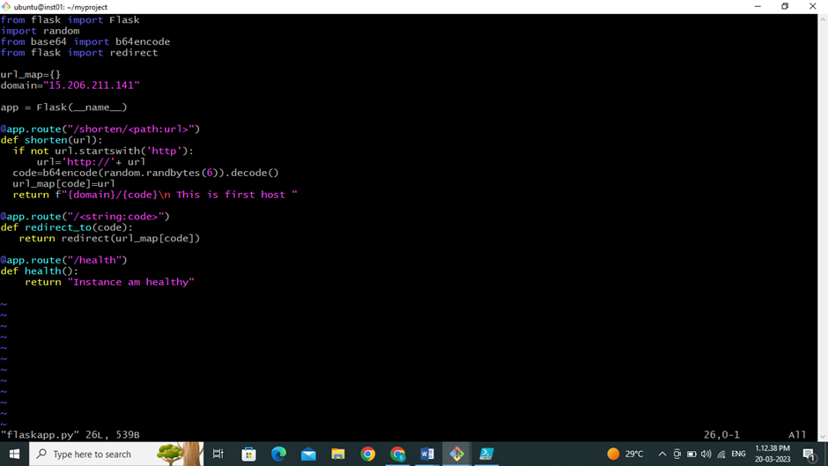

Use this flask application to create a shorten url for long one and save the file with flaskapp.py extension.

run app through localhost

**$ export FLASK_APP=my_flask**

**$ Flask run -h 0.0.0.0**

**$ curl** [**http://172.31.2.75:5000/shorten/www.google.com**](http://172.31.2.75:5000/shorten/www.google.com)

